GA Parameters:

This genetic algorithm is used to evolve L-creatures which are worm-like creatures with morphologies based on L-strings. The worm-like creature must absorb nutrients from its immediate environment.

The GA fitness metric is the absorption area of the L-creature where a higher absorb area means more nutrients. Figure 1 depicts such a creature with the body in red and the absorb area in blue.

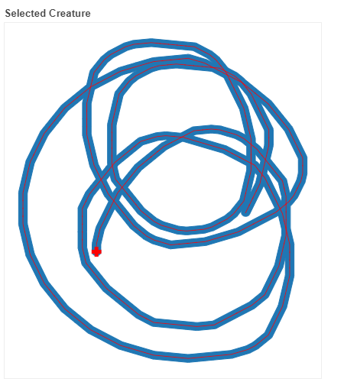

Figure 1

# Population size:

Variable, however 800 seems to be most promising

# L-string parameters:

No. of characters: 501

Axiom: FX

Variable: X

Constants: F - Unit step forward

+ - Positive direction angle change

- - Negative direction angle change

Rules: 5 x random.choice([‘F’, ‘+’, ‘-‘])

Area: L-creature body buffered by half a unit

(Area can be approximated by counting ‘F’ characters i.e. 20 F’s ≈ 20 Area)

# First population:

Randomly generated L-strings using two rules and an axiom. Subsequent generations were not generated.

# Selection:

## Random:

Percentage: 20%

Randomly select individual from current population for next population.

## Elitism:

Percentage: 30%

Sort by area and select top 30% for next generation.

## Mutation:

Percentage: 20%

Select random individual from **elite** group and mutate random 60% of characters using random.choice([‘F’, ‘+’, ‘-‘])

Mutation percentage has also been varied but does not seem to affect stagnation.

## Crossover:

Percentage: 30% - *remainder*

Select two random individuals from **elite** group. Select random index between 0 and 501. Perform crossover with these two individuals at randomized index.

# Some results:

# 

Figure 2 - 500 population size

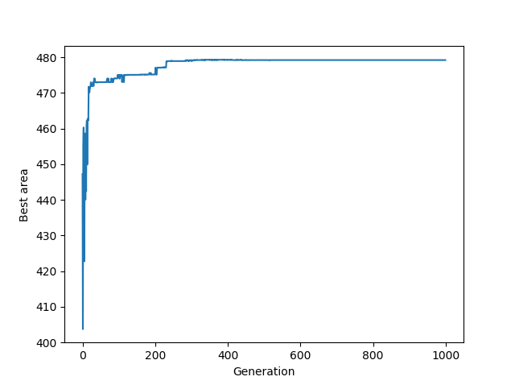

Figure 3 - 800 population size

# 

Figure 4 - 1000 population size

The jump at the end was a bug in the package that I was using. Usually after buffering, the result is a polygon with internal and external coordinates but here, for some reason, it was multiple polygons and the area was calculated using the convex hull of all the polygons.